Bye-bye Golden Rule 2

Task 1: The non-inverting comparator
All of the op-amp circuits up to now have used negative feedback and so have obeyed both golden rules. This time we shall look at one application that does not use negative feedback and so does NOT obey the second golden rule, although the first is always obeyed.
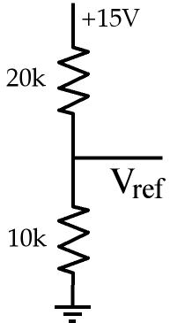
a) Build the circuit on the left. Calculate the output voltage, Vref.
5V.

b) Compare with the measured voltage.
5.00V. The measured value agrees with the theory.
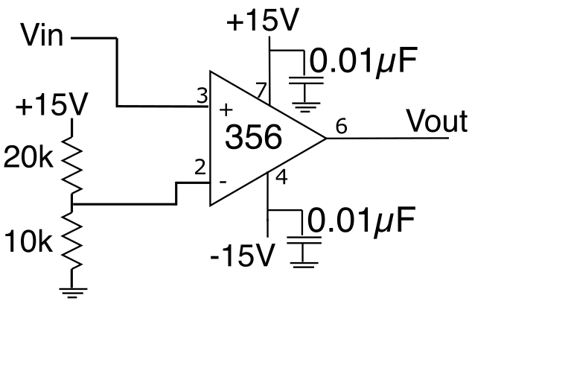

c) Add the comparator to get the circuit shown on the right. Connect Vin to the 50 Ohm output of your Instek signal generator and set the output to a ±15V triangle wave
Using the information from the scope, construct a plot of Vout vs. Vin and paste the plot below.
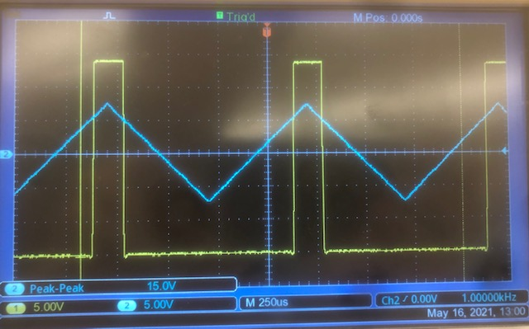

d) Explain your plots. In particular account for the value of the input voltage at which the output changes state.
When the triangle wave crosses above 5V, the output goes high. This makes sense; the comparator’s output is high if and only if the triangle wave’s voltage is greater than the voltage divider’s output voltage.

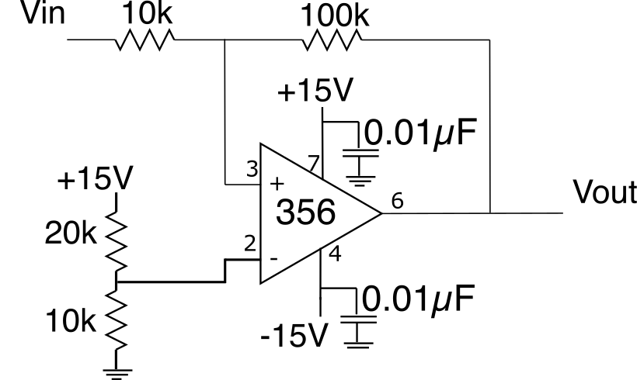
e) Add hysteresis resistors to the comparator as shown in the figure. Using the equations from Chapter 23 (section 23.1.2) compute the high and low level switching points that you PREDICT for this circuit.
V_H = 7.0
V_L = 4.0

f) Now measure Vout as a function of Vin and plot the results. You should use the same triangle-wave method to measure the transition points as in step 2.
Please be as quantitatively accurate as you can. That is, measure the voltages as accurately as possible.
V_H: 7.20
V_L: 4.20

g) Compare the results with your prediction.
My results are within a reasonable margin of error from my prediction.

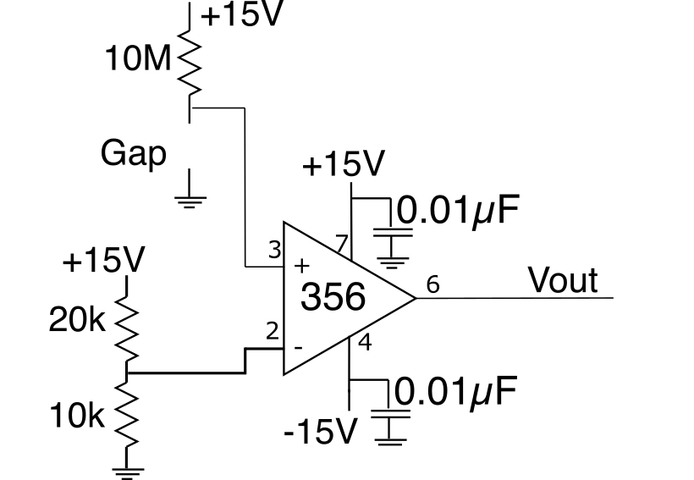

h) Use your comparator to build a touch switch following the circuit on the right. The output should change state when you bridge the gap with your fingers.
Hint: I have found that plugging in a 0.1µF capacitor between the + input of the LF356 and ground is a good way to make the gap. Then I grasp the capacitor leads between thumb and forefinger, to bridge the gap and switch the output.
Verify that it works and explain HOW it works.
The switch works because the resistance of my finger is such that the voltage drop across the 10M resistor is greater than 10V, so the non-inverting input of the op-amp is at a lower voltage than the inverting input, causing the output of the comparator to drop.

i) Explain why I chose such a large resistor to put in series with the gap.
You chose a large resistor because fingers have pretty high resistances, so a smaller resistor would not have a sufficient voltage drop to switch the comparator.

j) If you want to be cute you, can add an FET and lightbulb or LED (don't forget the resistor!!!) to the output and get a touch operated lamp.
Cool!

Task 2: The Inverting comparator
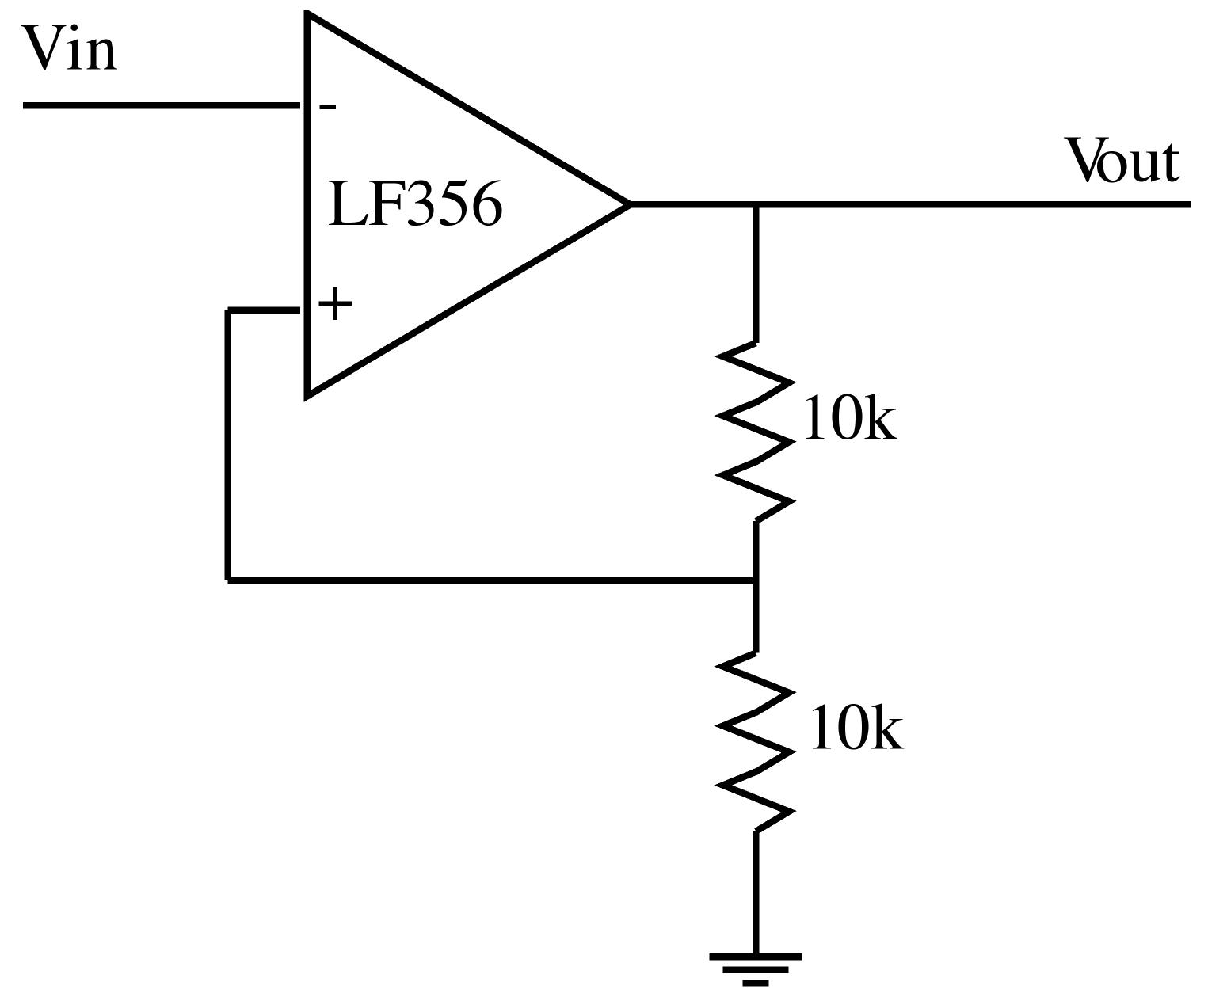
Next build the comparator shown on the left. Connect Vin to your Instek signal generator set to produce a triangle wave between +15V and -15V at about 100 Hz.
a) Reinterpret what you see on the scope and plot a graph of Vout vs. Vin.
REMEMBER Time is NOT one of your axes!

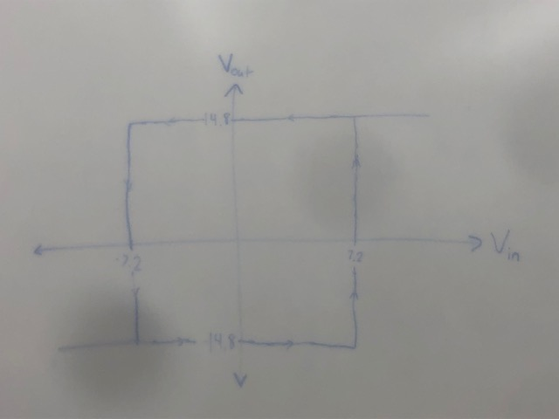
The switching voltages are +-7.2V, and the output voltage is +-14.8V.

b) Explain your results. In particular account for the transition voltages and compare their measured values with your theory.
Because there’s a 50% voltage drop across each 10k resistor, the non-inverting input will be at a voltage equal to half the output voltage. Since the output voltage is either 15V or -15V, it makes sense that the switcing voltages would be at around half of these values.

LEAVE THIS CIRCUIT SET UP ON YOUR BREADBOARD!!!!
If any time remains start lab 32.

